“FCL e-book”: Table of Contents. V2.9

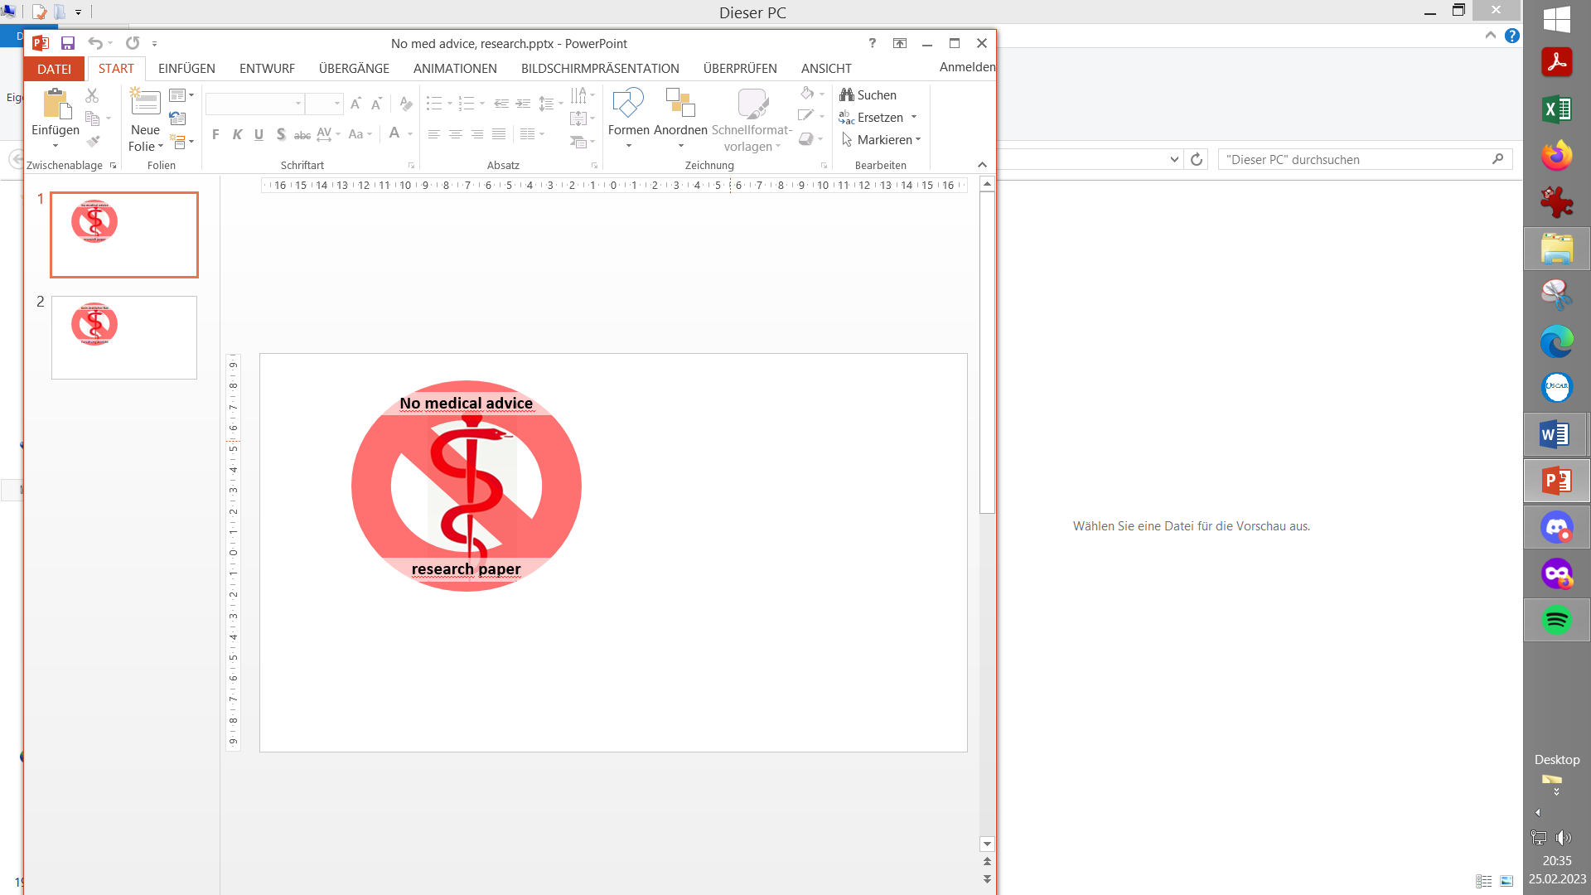

**0. Introduction**

**1. Pre-requisites for Full Closed Loop**

1.1 Well tuned hybrid closed loop

1.2 Fast insulin

1.3 Reliable insulin delivery from pump and cannula

1.4 Excellent CGM

1.5 Meal-related limitations?

1.6 Lifestyle-related limitations?

1.7 Time required for setting-up

Case study 1.1: Occlusion

Case study 1.2: Comparing insulins for FCL

Case study 1.3: Jumpy CGM

Case study 1.4: Lost pump connection

Case study 1.5: Permanent CGM values w/ 2x G6

**2. General Settings for Full Closed Loop**

2.1 SMB range extension

2.2 Max and min autoISF ratio

2.3 SMB delivery ratio

2.4 iobTH (iob_threshold_percent)

2.5 Eating Soon TT?

2.6 General settings in AAPS/Preferences

**3. Description of autoISF / guidance by developers**

3.1 Overview

3.2 ISF modulation flowcharts

3.3 Exercise mode and dynamic iobTH

3.4 Automation options with autoISF parameters

3.5 Activity monitor

3.6 Using one-minute CGM (Libre 3)

3.7 AutoISF parameters overview table

3.8 Emulator for logfile analysis and tuning

3.9 Links to related case studies/detailed doc.s

**4. Meals: Setting ISF_weights in AAPS/Preferences**

4.1 Getting started

4.2 bgAccel_ISF_weight

4.3 pp_ISF_weight

4.4 bgBrake_ISF_weight

*Skip what is in* ***green writing***: = Drafted fragments or not implemented ideas.

Please contribute, or wait for update with the missing info

4.5 dura_ISF_weight

4.6 Tuning your initial settings

4.7 Complex scenarios

4.8 Profile helper

Case study 4.1: Pizza

Case study 4.3: Hands-off FCL around Christmas

**5. Temp. modulation of autoISF aggressiveness**

**5.1 Automatic modulation of loop aggressiveness**

5.1.1 autoISF off outside of meal windows

5.1.2 SMB off @ odd profile target

5.1.3 SMB off @ odd temp. target

5.1.4 Automatic diff. of FCL aggressiveness via Automations

5.1.5 Automatic diff. of FCL aggressiveness via Activity Monitor

5.1.6 Pro/con completely hands-off FCL

**5.2 Manual modulation of FCL aggressiveness via DIY cockpit**

5.2.1 Status recognition

5.2.2 Manual interventions from DIY cockpit

5.2.2.1 Temp. %profile or TT settings

5.2.2.2 Temp. settings in /preferences

5.2.2.3 Grey DIY cockpit buttons for pre-programmed FCL responses

5.2.3 Temporary exit from FCL

**5.3 Manual modulation of FCL aggressiveness via improved cockpit**

5.3.1 Violet FCL icon and underlying buttons

5.3.2 Bottom buttons “insulin” etc.

5.3.3 Top three fields

5.3.3.1 TT dialogue field

5.3.3.2 Exercise button / dialogue field

5.3.3.3 Profile dialogue field

**5.4 Recognizing loop state from the AAPS home screen**

5.4.1 Color scheme (grey/yellow) of the top 3 fields (profile, exercise, TT)

5.4.2 Info on the top 3 fields (profile, exercise, TT)

5.4.3 FCL related indicator fields

5.4.4 Overall AAPS home screen

Case study 5.2: Sweet snacks / Glühwein w/ DIY cockpit

**6. Temp. modulation for exercise and light (In-)activity**

**6.1 Dynamic iobTH and sensitivity ratio**

6.1.1 Manual (direct) iobTH modulation

6.1.2 Automations for iobTH modulation

6.1.3 Dynamic iobTH

*Skip what is in* ***green writing***: = Drafted fragments or not implemented ideas.

Please contribute, or wait for update with the missing info

**6.2 Temp. % profile switch**

**6.3 DIY cockpit based on User action Automations**

**6.4 Improved FCL cockpit**

6.4.1 Manual (direct) iobTH modulation

6.4.2 pre-set 4 kinds of exercise

6.4.3 optional meal pre-sets

6.4.4 optional hypo management pre-sets

**6.5 Mastering the exercise after meal challenge**

6.5.1 Manual mode

6.5.2 DIY cockpit button for User action Automation

6.5.3 Using pre-sets in improved FCL cockpit

**6.6 Activity monitor based on step-counter**

Case study 6.2 Biking day with hi carb lunch; DIY cockpit

**7. Advanced HCL (meal announcement via pre-bolus)**

7.1 Hurdles for FCL

7.2 Getting ready to advance from HCL

7.3 Reduced pre-bolus

7.4 Tuning autoISF in HCL

7.5 Dealing with disturbances/ins. sens/resistance

7.6 Exercise management

7.7 Remote control (small children) (fragment, to be completed NN)

7.8 Other methods w/ meal announcement (MA)

**8. Performance monitoring and tuning**

Case study 8.2: Futility of tuning based on 1 extreme meal

**9. Trouble shooting**

**10. Emulator on PC to determine settings**

10.1 Installing the Emulator on your PC

10.2 Analyzing loop decisions in logfiles

10.3 What-if analysis

**11. Emulator on the smartphone**

11.1 Installing the emulator on your smartphone

11.2 Checking loop decisions on the smartphone

11.3 Options available on i-Phone (for Trio or iAPS)

11.4 Real-time checking a „what-if“ question using speech synthesis

**12. Remarks for users of previous autoISF version**

**13. Other avenues to Full Closed Loop**

**13.1 FCL using AAPS Master and Automations**

Case study 13.1: Comparison 1 mo FCL Automation vs autoISF

**13.2 dynamicISF used for Full Closed Loop**

Case study 13.2: Using dynISF for FCL ( NN )

**13.3 Methods involving simple meal announcement that might be stretched into a FCL**

13.3.1 Boost

Case study 13.3: Boost-based FCL for a child

13.3.2 AIMI,

13.3.3 EatingNow

13.3.4 Tsunami

**13.4 No-bolus looping with precise carb Inputs**

**13.5 Machine Learning (AI)**

**13.6 Dual hormone systems**